Name: ________________________________________________________ Science Distance Learning

Science Distance Learning: Refraction of Light from an Arrow Through Water
Supplies Needed
Piece of Paper,
Marker
Glass
Water
Step 1 – Get a sheet of paper and draw two arrows on it using a marker. Draw one arrow near the top of the paper and one arrow near the bottom. Make the arrows point in the same direction. You can use a straightedge to make the arrows if you want
Step 2 – Fill a clear glass with water.
Step 3 – Slowly lower the piece of paper behind the glass of water.
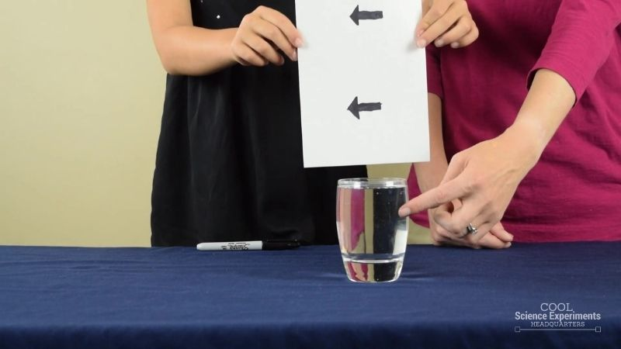
Observation: What do you see happening? ____________________________________________________
________________________________________________________________________________________
________________________________________________________________________________________
________________________________________________________________________________________
The scientific concept that is at work in this experiment is called refraction. Refraction is the bending of light. Refraction occurs when light travels from one medium to another. (ie. air to water, water to air). Mediums, defined in the physical sciences, are substances, such as air, water, or glass that make possible the transfer of energy, such as light or heat, from one location to another.

During the experiment, the light traveled from the image of the arrow through the air, then through the glass cup into the water, and finally out of the glass cup and into the air once more before it reached our eyes. Light refracts as it passes from one medium to the next because light travels at different speeds through those mediums. Light travels fastest through air, a little slower through water, and even slower through glass.

This means that the light bends once when it travels through the glass cup into the water, and then it bends again when it travels out of the glass cup and into the air. As a result, the light paths cross and the image appears to be flipped horizontally (left/right).

Directions: Read the above information and answer the questions below. Questions are in order of when they are discussed in the paragraphs below:
What is the scientific concept that is at work in the experiment? ____________________________________
What is refraction? ________________________________________________________________________
________________________________________________________________________________________
How are mediums defined in the physical sciences?_____________________________________________
________________________________________________________________________________________
________________________________________________________________________________________
What medium is the glass cup made out of? ____________________________________________________
What medium filled the cup? ________________________________________________________________
What medium is between the image of the arrow and the cup of water? _______________________________
What medium is in the cup of water? __________________________________________________________
What medium is between the cup of water and your eyes? _________________________________________
What does light do when it passes from one medium to another? ___________________________________
Why does light refract (bend) as it passes through one medium to the next? __________________________
During the experiment, what medium did light from the image travel through just before . . .
. . .it reached the glass of water? _____________________________________________________________
. . . it reached the water inside the glass? ______________________________________________________
. . . the light traveled out of the glass of water? __________________________________________________
. . . the light reached our eyes? ______________________________________________________________
Which medium used in the experiment does light travel fastest? ____________________________________
Which medium used in the experiment does light travel slowest? ___________________________________
Which medium used in the experiment does light travel slower than in air but faster than in water? ________
How many times does light bend as it travels through the mediums in the experiment? __________________
When does the light first bend in the experiment? ________________________________________________
When does the light bend again for a second time in the experiment? ________________________________
What happens to the paths of the light rays as a result of being bent twice? ___________________________
________________________________________________________________________________________
How does the image of the arrow appear because of this bending or refraction of light? __________________
________________________________________________________________________________________
The diagram below shows what our eye sees as light from the image of the arrow travels through the air to reach our eyes.
In the diagram below:
What media is represented by the white area? _________________________________________________
What are the red arrows pointing to? _________________________________________________________
What do the red arrows represent? __________________________________________________________
Draw (in the space below) what the person viewing the arrow would see:

Make your drawing in the space below:

The diagram below represents what a person would see looking at the image of an arrow drawn on a paper held behind a glass of water.
In the diagram below:
What is represented by the white shaded area? _______________________________________________
What is represented by the blue shaded area? ________________________________________________
What happens when the light rays reflecting off the arrow . . .
. . . travel through the air and enter the glass of water? ___________________________________________ . . . travel out of the glass of water and go in the air again? ________________________________________
________________________________________________________________________________________
. . . reach the focal point? ___________________________________________________________________
________________________________________________________________________________________
. . . reach our eyes? _______________________________________________________________________



